I Kain frassek declare I did not plagiarize to get any of this information in section 1.

Week 3

Q 1.1

Specification

|  |  |
| --- | --- |
| USB input | This must be a micro-USB input. It must be able to output between 4.5 and 5.5 volts which can then be used to charge the battery. It will need to be able to withstand high temperatures such as up to 80 degrees Celsius. |
| battery charger | The battery charger must be able to take the 5 Volt voltage source from the micro USB and charge the battery. It will indicate when the battery is fully charged using a green LED and when the battery is still charging using a red LED. It must also be able to withstand temperatures up to 80 degrees. |
| Undervoltage lockout | This must be connected to the lithium-ion battery. It must ensure that if the voltage provided by the battery goes below 3.3 volts no voltage is provided to the main circuit. |
| Battery | This must be a lithium ion battery that fits into the [BH-18650-B1BA002](https://jlcpcb.com/partdetail/Myoung-BH_18650B1BA002/C2988620) holder. It must be a 3.3 Volt battery. It must be able to withstand temperatures around 80 degrees Celsius. |
| Battery terminal pins | These need to be 2 pins that can be used to provide 3.3 volts to the main circuit in case the battery is not available or for testing purposes. |
| Reverse polarity protection circuits | This must be connected to the battery. It must be able to detect whether the batteries polarity has been swapped or if the polarity at which the battery is being charged is in the wrong direction. If the polarity in either case has been swapped it must prevent the main circuit and battery, from being powered or charged by this voltage. |
| 3.3 Volt regulator | This circuit must be able to take the voltage from the battery which will be 3.3 volts or higher and regulate it so that a constant 3.3 volts is supplied. This can then be used to power our circuit reliably. |

Q1.2

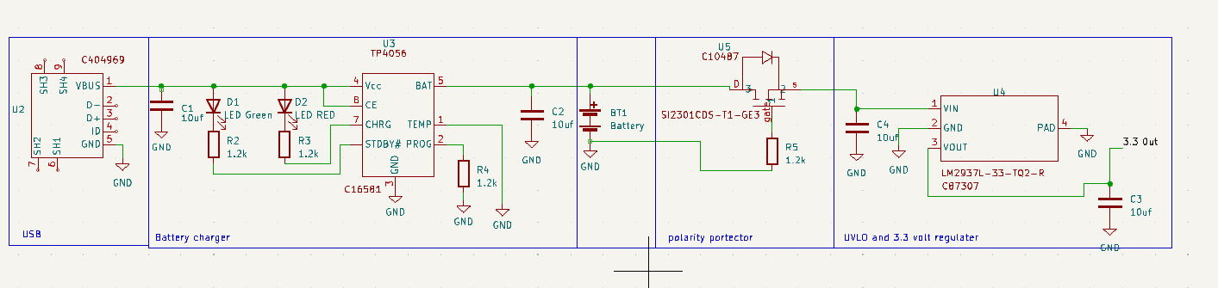

Q.1.3

Submodule interface

|  |  |
| --- | --- |
| LED is used to indicate the charging of the battery. | one green LED and one red LED. Both in series with 1.2 KΩ resistors to reduce current. |
| STM32F051C6Tx | This is the main microprocessor board which will need to be supplied with 3.3 volts. current used to power itself is between 3 and 4.5 milliamps. |
| Potentiometer analog sensor | This will be supplied with 3.3 volts and will act as a voltage divider. It will draw 33 milli amps of power. |
| digital light sensor | This will be supplied 3.3 volts. And will draw a very low current. |
| Outputs via LED | There will be an LED powered by the 3.3 volts which can be used to flash at different rates and help give outputs about what has been sensed. These LED's will be put in series with large resistors to help reduce current. |
| Debug (SIL 1x10 Male) | This will need a 5 Volt power supply and therefore it will need to be supplied straight from the USB port. |
| Analogue sensor 2 thermister | This will need 3.3 V power supply and should draw les that 1 mw of power. |
| USB connector | Will supply 5V to the main power circuit. An external USB cable will be connected to provide this power and for data transmission |